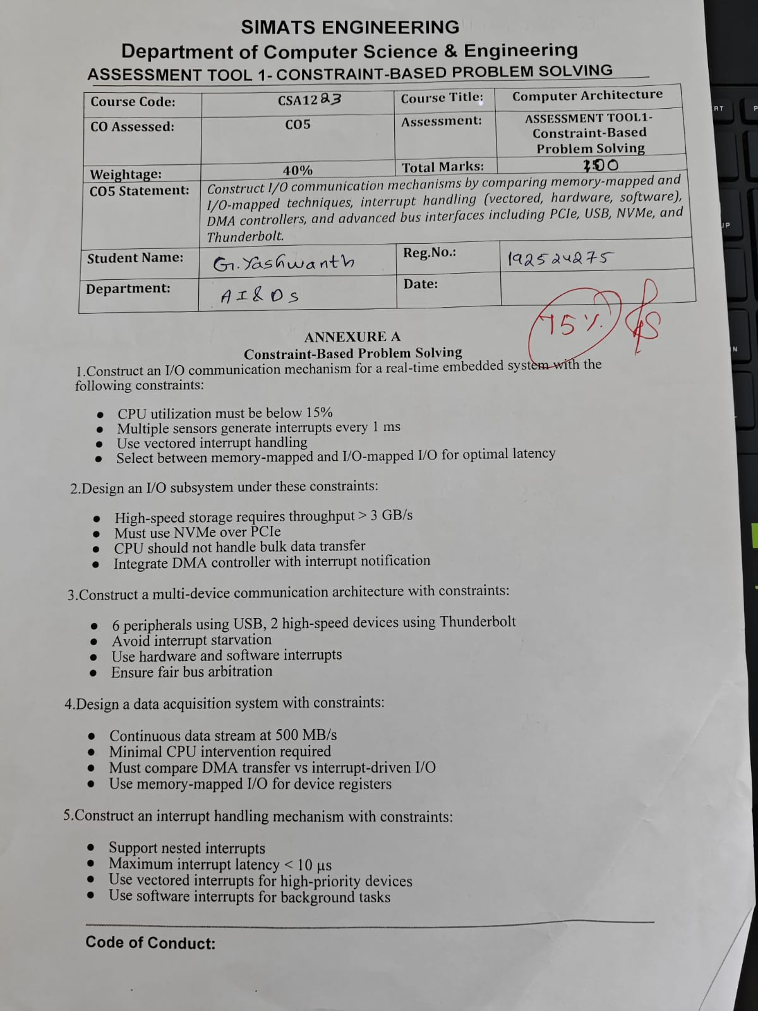

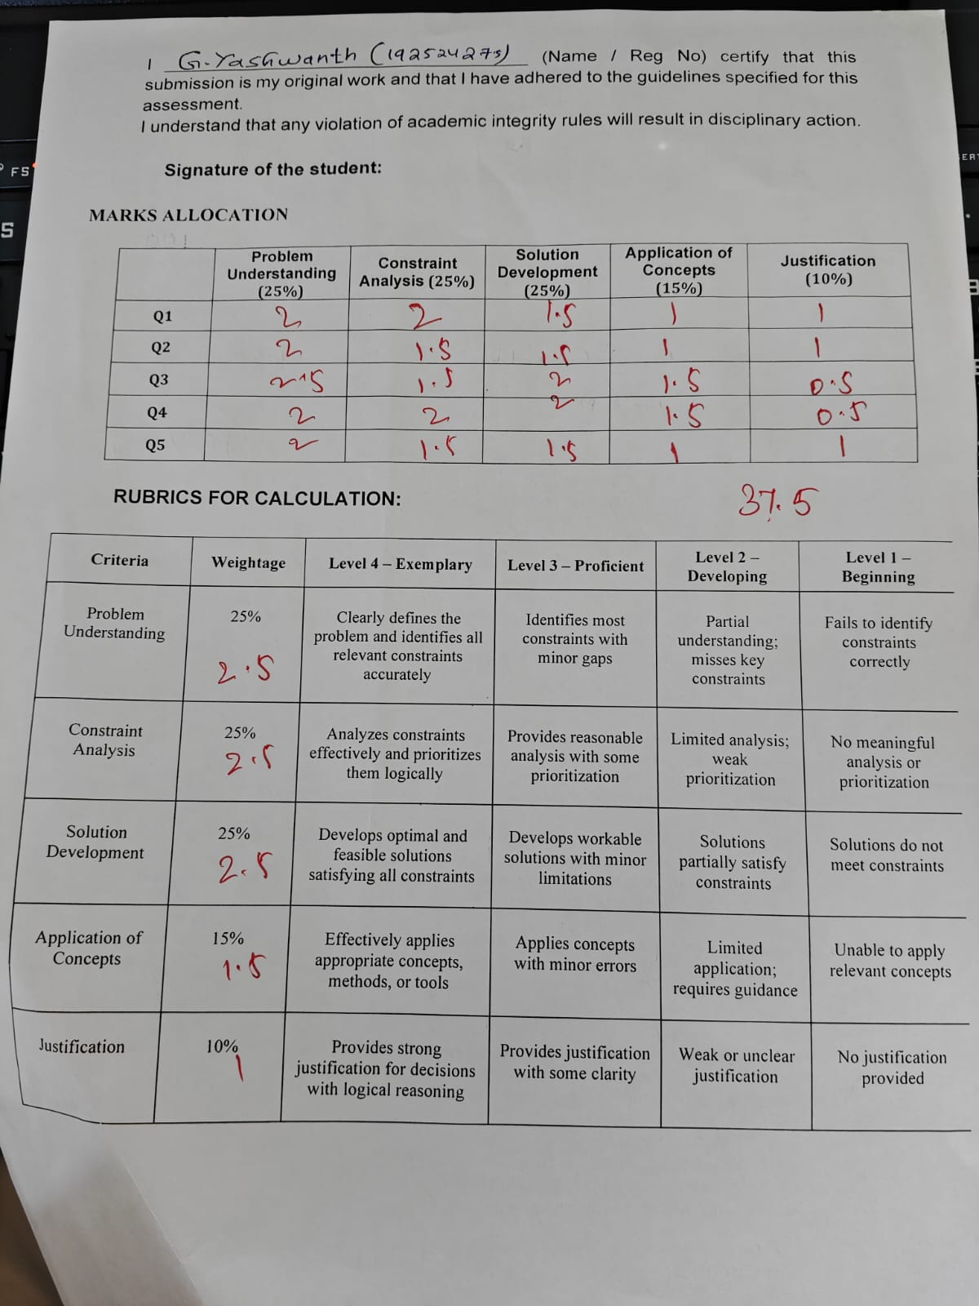

1. Real-Time Embedded System I/O Communication

Given Constraints
- CPU utilization must be below 15%
- Multiple sensors generate interrupts every 1 ms
- Use vectored interrupt handling
- Select the I/O method with minimum latency

Design
Use memory-mapped I/O + vectored interrupt controller + DMA.

Components
- Sensors
- Interrupt Controller
- CPU
- DMA Controller
- Main Memory
- Memory-mapped I/O registers

Diagram
Sensors
↓
Interrupt Controller
↓
Vectored Interrupt
↓
CPU
↓
DMA
↓
Main Memory

Working
- Sensors continuously generate data.
- When a sensor needs attention, it generates an interrupt.
- The interrupt controller identifies the sensor and sends its vector number to the CPU.
- CPU directly executes the corresponding ISR.
- DMA transfers sensor data directly to memory.
- CPU does not handle every data byte.

Why Memory-Mapped I/O?
Memory-mapped I/O provides fast access to device registers and reduces the time required for I/O operations.

Final Choice
Memory-mapped I/O + vectored interrupts + DMA
Reason: Low latency and reduced CPU utilization help keep CPU usage below 15%.

2. High-Speed Storage I/O Subsystem

Given Constraints
- Throughput must be greater than 3 GB/s
- Must use NVMe over PCIe
- CPU should not handle bulk data
- DMA and interrupt notification are required

Design
Use an NVMe SSD connected through PCIe with DMA.

Components
- CPU
- PCIe Bus
- NVMe Controller
- NVMe SSD
- DMA Controller
- Main Memory
- Interrupt Controller

Diagram
CPU
│
NVMe Command
│
▼
PCIe Bus
│
▼
NVMe Controller
│
▼
NVMe SSD
│
DMA
│
▼
Main Memory
│
▼
Interrupt → CPU

Working
- CPU sends an NVMe command.
- PCIe transfers the command to the NVMe controller.
- NVMe SSD reads/writes the data.
- DMA transfers bulk data directly between SSD and main memory.
- CPU receives an interrupt after the transfer is completed.

Why DMA?
DMA transfers large amounts of data without continuous CPU involvement.

Final Choice
NVMe + PCIe + DMA + Interrupt
Reason: Provides high-speed storage transfer above 3 GB/s while reducing CPU workload.

3. Multi-Device Communication Architecture

Given Constraints
- 6 USB peripherals
- 2 Thunderbolt high-speed devices
- Avoid interrupt starvation
- Use hardware and software interrupts
- Fair bus arbitration

Design
Use separate USB and Thunderbolt controllers connected through a fair bus arbiter.

Diagram

CPU
↓
Bus Arbiter
↙ ↘
USB Controller Thunderbolt Controller
↓ ↓ ↓ ↓ ↓ ↓ ↓ ↓
U1 U2 U3 U4 U5 U6 T1 T2

Working
- Six devices communicate through the USB controller.
- Two high-speed devices use the Thunderbolt controller.
- The bus arbiter controls which device gets access to the bus.
- Round-robin arbitration gives each device a fair opportunity.
- Hardware interrupts handle urgent device events.
- Software interrupts handle background tasks.

How is Starvation Avoided?
Use round-robin arbitration, where each device gets its turn.

Final Choice
USB Controller + Thunderbolt Controller + Round-Robin Arbiter + Hardware/Software Interrupts

4. Data Acquisition System

Given Constraints
- Continuous data rate = 500 MB/s
- Minimum CPU intervention
- Compare DMA and interrupt-driven I/O
- Use memory-mapped I/O

Design
Use memory-mapped I/O + DMA + ring buffer.

Diagram
Data Acquisition Device
│
500 MB/s
│
▼
DMA Controller
│
▼
Ring Buffer
Main Memory
│
▼
CPU
▲
│
DMA Completion
Interrupt

Working
- The data acquisition device continuously generates data.
- Device registers are accessed using memory-mapped I/O.
- DMA transfers data directly into the ring buffer.
- CPU processes the data from memory.
- DMA generates an interrupt after completing a block transfer.

DMA vs Interrupt-Driven I/O
Factor | DMA | Interrupt-Driven I/O
CPU involvement | Very low | High
Data transfer | Device → Memory | Device → CPU → Memory
CPU overhead | Low | High
Suitable for 500 MB/s | Yes | No
Performance | High | Lower
Continuous transfer | Suitable | Less suitable

Final Choice
DMA is preferred.
Reason: 500 MB/s is a very high continuous data rate. DMA transfers data directly to memory and greatly reduces CPU intervention.

5. Nested Interrupt Handling Mechanism

Given Constraints
- Support nested interrupts
- Interrupt latency must be less than 10 µs
- High-priority devices use vectored interrupts
- Background tasks use software interrupts

Design
Use a priority-based interrupt controller with nested interrupts.

Diagram
Devices
│
▼
Priority Interrupt
Controller

┌───────┴────────┐
│ │
▼ ▼
High Priority Low Priority
Device Device
│ │
▼ ▼
Vectored ISR Normal ISR
│ │
└──────┬─────────┘
▼
Nested Interrupt
│
▼
Restore Context
│
▼
Continue ISR
Background Tasks
│
▼
Software Interrupt

Working
- Devices generate interrupts.
- The interrupt controller assigns priority.
- High-priority devices use vectored interrupts.
- If a high-priority interrupt occurs while a low-priority ISR is running, it temporarily interrupts the low-priority ISR.
- CPU saves the current context.
- High-priority ISR executes first.
- CPU restores the previous context and continues the interrupted ISR.
- Background tasks use software interrupts.

How to Achieve <10 µs Latency?
- Use vectored interrupts.
- Keep ISRs short.
- Use hardware priority levels.
- Avoid unnecessary processing inside the ISR.
- Use fast interrupt-controller hardware.

Final Choice
Priority-based nested vectored interrupts + software interrupts
Reason: High-priority devices receive immediate service while background tasks are handled separately.
窗体顶端

窗体底端

